**Module ICT3715**

## 2021

**INFORMATION AND COMMUNICATION TECHNOLOGY**

**ASSIGNMENT 2**

**DUE DATE: 28 May 2021**

|  |  |  |  |  |  |  |  |  |  |
| --- | --- | --- | --- | --- | --- | --- | --- | --- | --- |
| STUDENT NUMBER (Student completes) | | | | | | | | | |
|  |  |  |  |  |  |  |  |  |  |

|  |  |  |  |  |  |  |  |  |  |  |  |  |
| --- | --- | --- | --- | --- | --- | --- | --- | --- | --- | --- | --- | --- |
| **IDENTITY NUMBER (Student completes)** | | | | | | | | | | | | |
|  |  |  |  |  |  |  |  |  |  |  |  |  |

*No handwritten assignments will be accepted.*

**INSTRUCTIONS:**

**Instructions for the student:**

*Complete this front page (page 1).*

*Complete the Plagiarism Pledge (page 2). Your assignment will not be assessed without this.*

*After you’ve completed the front page with your information, the plagiarism pledge and section A, save the document as a PDF. Keep a copy of the original should there be problem with the upload.*

**PLAGIARISM PLEDGE BY THE STUDENT**

1. I have read Unisa’s plagiarism policy.
2. I understand Unisa’s plagiarism policy.
3. I agree to abide by Unisa’s plagiarism policy.
4. I have read the direct copying, plagiarism, and “patch-writing” document.
5. I understand what direct copying, plagiarism, and “patch-writing” is.
6. I undertake to avoid copying directly, plagiarism and patch writing.
7. All academic work, written or otherwise, that I submit is expected to be the result of my own skill and labour.
8. I understand that, if I am guilty of the infringement of breach of copyright/plagiarism or unethical practice, I will be subject to the applicable disciplinary code as determined by Unisa.
9. The marker has the right to refuse to assess the assignment and the system if plagiarism is detected.

Student name and Surname: _______________________________________

Student number: ______________________________

___________________________ ___________

Student signature*: Date:

[*You can add a digital signature as well]

SECTION 0

Identify the database that you are using: (no mark)

Mysql database

Which section of the OEP are you developing (MCQ, Fill-in or File-Upload)? (no mark)

MCQ

ERD that you created in Assignment 1 (will be used by marker to verify that the data imported in the database is reflecting the tables and column in your ERD (no mark)



SECTION A

1. Describe, in detail, the process that you followed in importing the .csv file into your database of choice. Be very specific. Identify any problems and describe how you have solved it. You may add screen dumps, examples, etc. as evidence. (15)

Login to your cPanel and go to phpMyAdmin.  
created a database first on phpMyAdmin under xampp after that

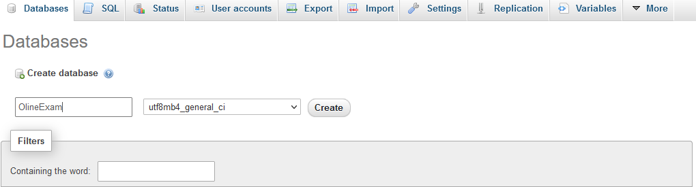  
    1. I Selected the database that was created and then table from left side panel.

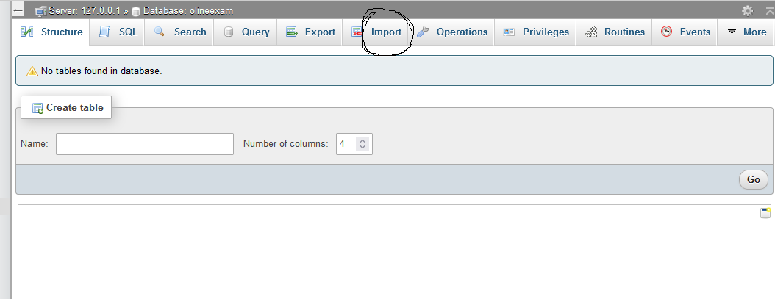

    2. Click on **Import** tab.

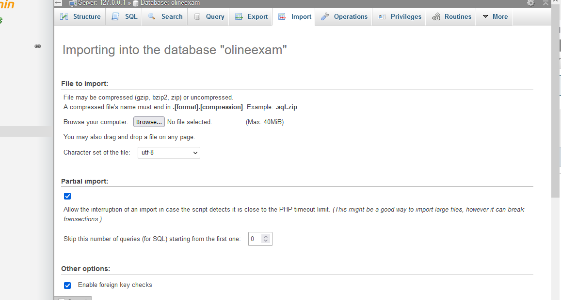  
    3. Click the Choose file button to browse to local csv file.

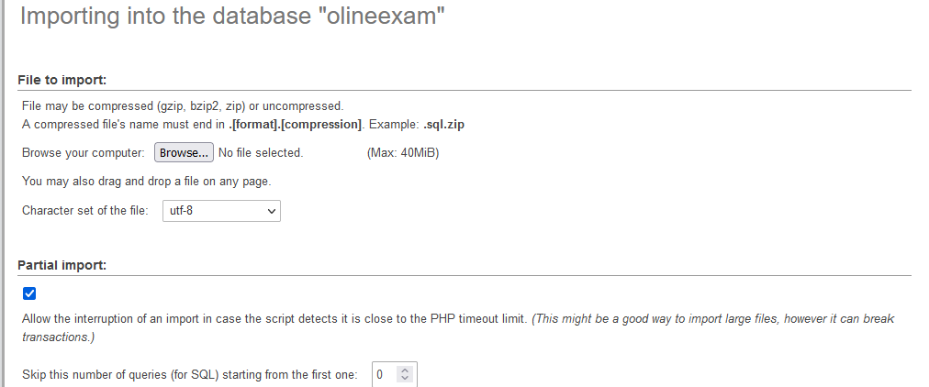

    4. And I Selected the 'CSV using LOAD DATA' for **Format**.

    5. Choose other Format-Specific Options.  
    5. Click **Go**

SECTION B

Describe the backup and recovery processes that you have put in place to (1) backup your data on a regular basis and (2) recover the data should it be required. (15)

Before I mention the method I have used for my backup and recovery, let me explain **exactly what is backup and recovery?**

Backup and recovery describe the process of creating and storing copies of data that can be used to protect organizations against data loss. This is sometimes referred to as operational recovery. Recovery from a backup typically involves restoring the data to the original location, or to an alternate location where it can be used in place of the lost or damaged data.

In this case I am going to use online planform called **GitHub** to store and recovery my data

How did I set up my **GitHub account?**

You will need a GitHub account to create a GitHub repository where the data will be stored.

1. Go to [https://github.com/join](https://github.com)
2. Type a user name, your email address, and a password.
3. Choose **Sign up for GitHub**, and then follow the instructions.

Step 2: Create a **GitHub repository**

On the [GitHub home page](https://github.com/dashboard)

1. I did the following:

* In **Your repositories**, choose **New repository**.
* On the navigation bar, choose **Create new** (**+**), and then choose **New repository**.
  1. In the **Create a new repository** page, do the following:

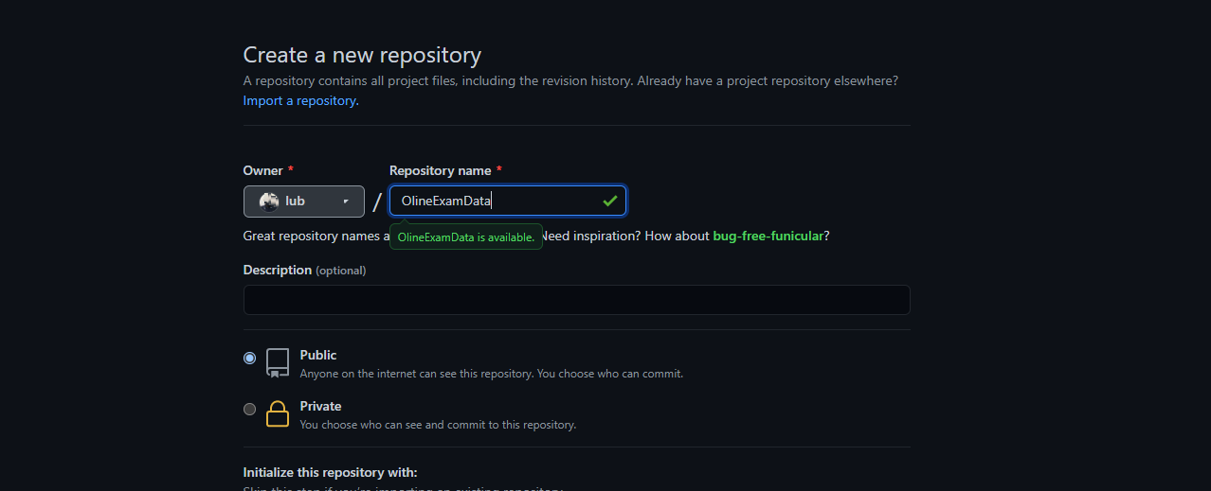

* In the **Repository name** box, enter CodeDeployGitHubDemo.
* Select **Public**.

Selecting the default **Public** option means that anyone can see this repository. You can select the **Private** option to limit who can see and commit to the repository.

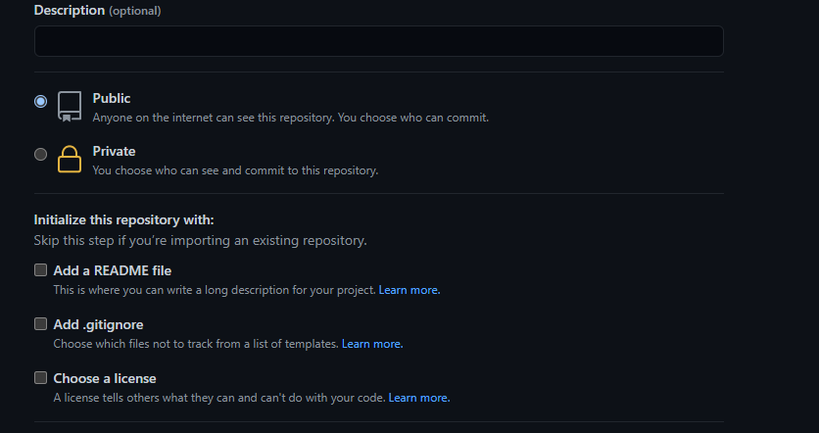

* 1. Clear the **Initialize this repository with a README** check box. You will create a README.md file manually in the next step instead.
  2. Choose **Create repository**.

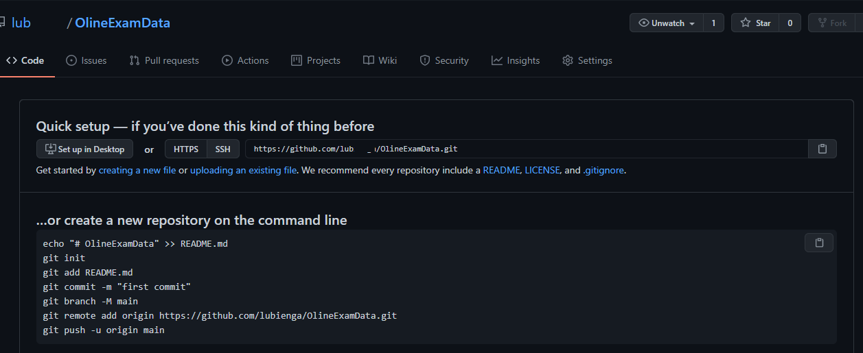

**TOTAL: 60**

Submitting the Assignment.

Complete this template. Save the document as PDF, e.g. 12345678_ICT3715_01.pdf, (replace 1234568 with your student number).

Submit this PDF together with the Screen Captures on or before the due date.